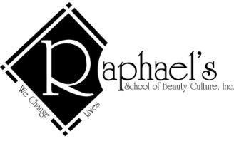
Student Salon

1. Everyone must sign in on this Client Service Form.
2. Everyone under 18 must also have a parent/guardian signature on all forms.
3. You must be at least 13 years old to receive any chemical service, artificial nail enhancement or spa service.

RELEASE OF LIABILITY: RAPHAEL’S SCHOOL OF BEAUTY CULTURE, INC. is a school for beauty culture and cosmetology. I understand that the operators in this school are not being held out as skilled professionals, but only as students. That as a consequence of this fact, I am receiving a reduction in the prices customarily charged for these services. Therefore, in consideration for these reduced charges and for the use of the services and facilities provided by RAPHAEL’S SCHOOL OF BEAUTY CULTURE, INC., I hereby understand and agree to release and hold harmless RAPHAEL’S SCHOOL OF BEAUTY CULTURE, INC., its employees, enrolled students, and instructors from any and all liability for injuries which I may sustain resulting from the negligence of RAPHAEL’S SCHOOL OF BEAUTY CULTURE, INC., its employees, enrolled students, and instructors. I further understand that the services being rendered to me are at my own and sole risk and I agree to release and hold harmless RAPHAEL’S SCHOOL OF BEAUTY CULTURE, INC., its employees, enrolled students and instructors from any injury to me and from the loss of any personal property of mine when on its premises. By signing the RELEASE OF LIABILITY, I have read and fully understand and agree to be bound by the terms.

